Helping Your Child to Read
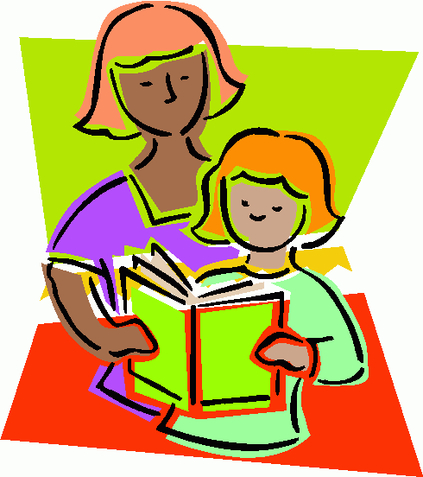
Reading at School
At school, the children are exposed to a ‘print-rich’ environment of signs, labels, books, key words, display and role play that all give opportunities for reading. There are also book areas where children can enjoy sharing books, listening to stories and reading. Children are taught daily Phonics through the ‘Little Wandle’ revised Letters and Sounds programme.
Although your child will be taught to read at school, you can have a huge impact on their reading journey by continuing their practice at home. There are two types of reading book that your child will bring home:
Sharing book
In order to encourage your child to become a lifelong reader, it is important that they learn to read for pleasure. The children will visit the school library on Tuesdays and will choose a sharing book to take home. Your child will not be able to read this on their own. This book is for you both to read and enjoy together. Discuss the pictures, enjoy the story, predict what might happen next, use different voices for the characters, explore the facts in a non-fiction book. The main thing is that you have fun!
Reading practice book
Once the children have settled into Reception and baseline assessments have been carried out, your child will bring home an individual reading book matched to the Phonic Phase they are currently working on in school, in order to match the child’s individual reading ability.
First reading books are lilac. Lilac books are to help the development of storytelling and an interest in books. There are pictures and some repetitive words. With lilac books, your role is to encourage ‘book talk’ in different ways:
Discuss the features
Ask questions and get children thinking
Discuss the pictures

Your child will be heard read once a week by the teacher/LSA to allow staff to monitor children’s independent reading skills, suitability of the book or readiness to move forwards.
Revisiting books with an adult at home allows for repetition which leads to greater acquisition of new vocabulary because children pick up new information with each re-read.
Children will change their reading and book once / twice a week, depending on the needs of your child.
Useful tips when reading with your child
Try to hear your child read every day. Little and often is more beneficial than a long session once a week. Think about how long you are reading for - the amount of reading time shouldn’t exceed your child’s span of attention. Pick your timing carefully - it’s best not to embark on a reading session when your child is tired.
Be positive! Remember to give them lots of praise – celebrate their success! Let them know it is alright to make mistakes. After they have finished, talk about the book together.
Turn off the TV! With no distractions, you can enjoy reading together.
Don’t make them try too hard! If your child is tired / struggling perhaps read the book to them. Make little mistakes, see if they can correct you. (They love this in class!)
Ask lots of questions. Check they understand the story by asking them questions about what happens.

How to encourage your child to read

Read yourself! Show a good example by sharing your reading: newspapers, magazines, and letters.
Keep books at home. Let your child know that books are part of your life. Keep a box of books in the car for long / short journeys.
Keep books safe. Make your child their own special place to keep their books. Talk to them about how to care for books.
Point out words all around you. Help your child to read the words around them: on food packets, in the Supermarket, on buses, in newspapers, in recipes.
Visit your Library – it’s free to join! All libraries have children’s sections. Some have storytelling sessions.
Make a time to read. Why not share a bedtime story? Encourage your child to join in the reading with you.
Let everyone help. Encourage your child to read with other people: Grandparents, brothers and sisters, aunties, uncles.

Make it fun!
- Buy books or book tokens as presents. Buy comics and magazines after school instead of sweets.
- Have a laugh reading joke books.
- Make your own books together. Write words and draw pictures for them.
- Play alphabet games and try to think of a word for every letter of the alphabet.
- Spend time chatting about books and stories.
- Tell stories with favourite teddies and toys.
- Make shopping lists and read recipes to cook things together.
- Play I-Spy
- Write stories and poems together.
- Listen to audio stories. These are great for car journeys.

Reading Record Book
As well as a school reading book your child will also have a ‘reading record book’ in which their progress will be monitored. This book also provides a means of communication between parents and the class teacher and your comments are of great value. Please record your comments in the book to help the teacher know how your child is getting on with reading at home.

Lastly
Remember, reading is not a race, it is a journey! If children are rushed through the books they will not achieve the enjoyment and understanding necessary.
If you have any worries or would like to know more about any part of the reading approach we will be more than happy to help.

Enjoy reading with your child and help them become lifelong readers.

Joanne Evans September 2021

